// Task-1:

#include <stdio.h>

#include <string.h>

struct process

{

int wt, at, bt, tat;

};

struct process array[10];

int main()

{

int value, temp[10];

int counter = 0, t = 0, idx;

float total_wt = 0, total_tat = 0, average_wt, average_tat;

printf("Total Process Count\n");

scanf("%d", &value);

printf("Enter the arrival time and burst time of the process\n");

printf("at wt\n");

for (int x = 0; x < value; x++)

{

scanf("%d%d", &array[x].at, &array[x].bt);

temp[x] = array[x].bt;

}

array[9].bt = 10000;

for (t = 0; counter != value; t++)

{

idx = 9;

for (int x = 0; x < value; x++)

{

if (array[x].bt < array[idx].bt && (array[x].at <= t && array[x].bt > 0))

{

idx = x;

}

}

array[idx].bt = array[idx].bt - 1;

if (array[idx].bt == 0)

{

counter++;

array[idx].wt = t+1-array[idx].at - temp[idx];

array[idx].tat = t+1-array[idx].at;

total_wt = total_wt+array[idx].wt;

total_tat = total_tat+array[idx].tat;

}

}

average_wt = total_wt / value;

average_tat = total_tat / value;

printf("wt tat\n");

for (int x = 0; x < value; x++)

{

printf("%d\t%d\n", x + 1, array[x].wt, array[x].tat);

}

printf("Avg waiting time of the process is %f\n", average_wt);

printf("Avg turn around time of the process %f\n", average_tat);

}

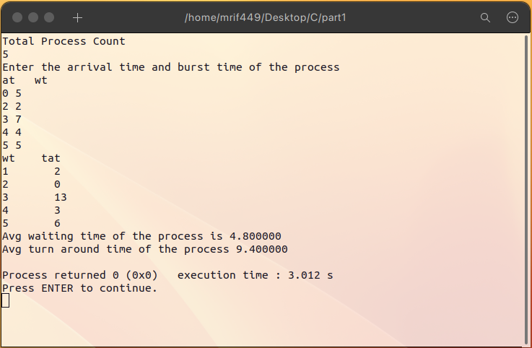

//Task-2:

#include <stdio.h>

#include <string.h>

void main()

{

int x, process_number, result = 0, counter = 0, y, tq, wt = 0, tat = 0, at[10], bt[10], flag[10];

float average_wt, average_tat;

printf("Total Process counter: ");

scanf("%d", &process_number);

y = process_number;

for (int x = 0; x < process_number; x++)

{

char var1;

int var2;

int var3 = 0;

scanf("%s %d",&var1,&var2);

bt[x] = var2;

at[x] = var3;

flag[x] = bt[x];

}

printf("Enter the Time Quantum:\t");

scanf("%d", &tq);

printf("\nProcess No\tBurst Time\t\t\tTAT\t\tWaiting Time ");

for (result = 0, x = 0; y != 0;)

{

if (flag[x] <= tq && flag[x] > 0)

{

result = result + flag[x];

flag[x] = 0;

counter = 1;

}

else if (flag[x] > 0)

{

flag[x] = flag[x] - tq;

result = result + tq;

}

if (flag[x] == 0 && counter == 1)

{

y--;

printf("\nP%d \t\t %d\t\t\t\t %d\t\t\t %d", x + 1, bt[x], result - at[x], result - at[x] - bt[x]);

wt = wt + result - at[x] - bt[x];

tat = tat + result - at[x];

counter = 0;

}

if (x == process_number - 1)

{

x = 0;

}

else if (at[x + 1] <= result)

{

x++;

}

else

{

x = 0;

}

}

average_wt = wt * 1.0 / process_number;

average_tat = tat * 1.0 / process_number;

printf("\nAverage Turn Around Time: \t%f", average_wt);

printf("\nAverage Waiting Time: \t%f", average_tat);

getch();

}

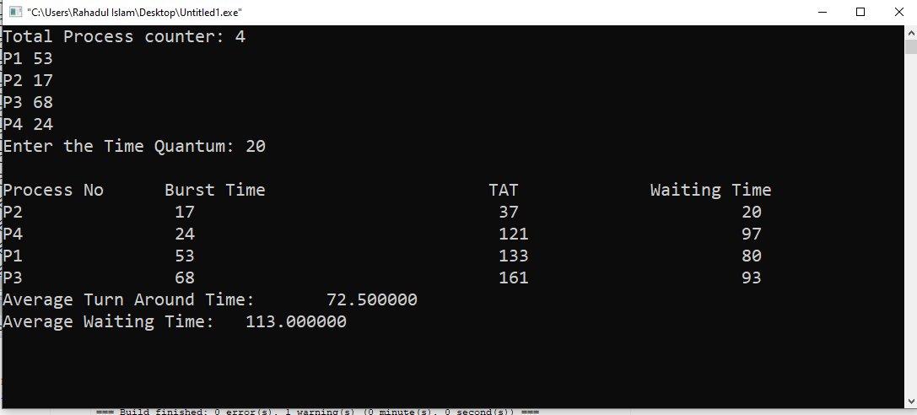

// Task-3:

#include <stdio.h>

#include <string.h>

struct process

{

int wt, at, bt, tat, priority;

};

struct process array[10];

int main()

{

int n, temp[10], t, count = 0, prior;

float total_wt = 0, total_tat = 0, average_wt, average_tat;

printf("Total Process Count\n");

scanf("%d", &n);

printf("at bt priority\n");

for (int i = 0; i < n; i++)

{

scanf("%d%d%d", &array[i].at, &array[i].bt, &array[i].priority);

temp[i] = array[i].bt;

}

array[9].priority = 10000;

for (t = 0; count != n; t++)

{

prior = 9;

for (int i = 0; i < n; i++)

{

if (array[prior].priority > array[i].priority && array[i].at <= t && array[i].bt > 0)

{

prior = i;

}

}

array[prior].bt = array[prior].bt - 1;

if (array[prior].bt == 0)

{

count++;

array[prior].wt = t+1-array[prior].at-temp[prior];

array[prior].tat = t + 1 - array[prior].at;

total_wt = total_wt + array[prior].wt;

total_tat = total_tat + array[prior].tat;

}

}

average_wt = total_wt / n;

average_tat = total_tat / n;

printf("WT TAT\n");

for (int i = 0; i < n; i++)

{

printf("%d\t%d\n", i + 1, array[i].wt, array[i].tat);

}

printf("Average Waiting Time of the process is %f\n", average_wt);

printf("Average turn around time of the process is %f\n", average_tat);

return 0;

}

